DYPIEMR(E&TC)

# Dr. D. Y. Patil Pratishthan’s

**DR. D. Y. PATIL INSTITUTE OF ENGINEERING, MANAGEMENT & RESEARCH**

# Approved by A.I.C.T.E, New Delhi , Maharashtra State Government, Affiliated to Savitribai Phule Pune University

Sector No. 29, PCNTDA , Nigidi Pradhikaran, Akurdi, Pune 411044. Phone: 020–27654470, Fax: 020-27656566

Website : [www.dypiemr.ac.in](http://www.dypiemr.ac.in/) Email : [principal@dypiemr.ac.in](mailto:principal@dypiemr.ac.in)

# Experiment No: 10

**Title: -**Study the network analyzer and carry out the measurements of s-parameters

## Theory: -

**Network Analyzer**

**A Unique Class of Instrument**

Network analyzers are powerful instruments that, when properly used, provide

unparalleled accuracy. Indispensable throughout an enormous range of applications

and industries, network analyzers are particularly useful in measuring linear

characteristics of radio frequency (RF) components and devices. You can also use

modern network analyzers in more specific applications, such as signal integrity and

materials measurement.



Figure 1: Vector Network Analyzer

**Network Analyzer Evolution**

You can use a vector network analyzer, such as the NI PXIe-5632 shown in Figure 1,

to measure device magnitude, phase, and impedance. Because a network analyzer is a

closed stimulus-response system, you can measure RF characteristics with exceptional

precision. Understanding basic network analyzer principles is a key to maximizing

your benefits with a network analyzer.

**Network Analysis Principles**

Network is a frequently used term that has many modern-day definitions. With

respect to network analysis, a network is a group of interconnected electrical

components. One function that a network analyzer performs is to quantify the

impedance mismatch between two RF components to maximize power efficiency and

signal integrity. Each time an RF signal leaves one component and enters another,

portions of the signal are reflected and transmitted. Consider the analogy shown in

Figure 2. Light from a source directs an incident signal at an optical device, such as a

lens. The lens is analogous to an electrical network. As light hits the lens, depending

on the properties of lens, some of the light is reflected back at the source, and some is

transmitted through. Conservation of energy requires that the sum of the reflected and

transmitted signal equals the source or incident signal. This example ignores any loss

due to heat, which is usuallynegligible.



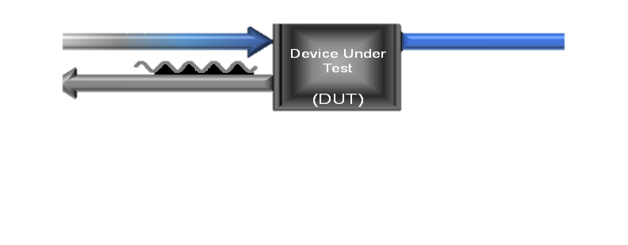

Figure 2: Analogy of Network Analyzer

**Network Analyzer Architectures**

Network analyzers are available as both scalar (magnitude only) and vector

(magnitude and phase) instruments. Scalar instruments were once widely used

because of their simplicity and lower cost. Vector instruments offer better error

correction and more complex measurement capability. With advances in technology,

integration, computing power, and cost reduction, vector network analyzers are

increasingly common. Network analyzers have four basic functional blocks, as shown

in Figure 3.



Figure 3: Architecture of Network Analyzer

A signal source, which produces the incident signal, is either swept or stepped in

frequency and you can adjust the power level. This source feeds into the DUT input

via the signal separation section, also known as a test set. At this stage, the reflected

and transmitted signals are separated into components. For each frequency point the

processor measures the individual signals, and computes the parameter value (for

example S21 or VSWR). User calibration, discussed in more detail later, provides

error correction that is applied to the data. Finally, when you interactively use a

network analyzer, you can view these corrected values on a display, which shows the

parameters and offers other user functionality, such as scaling.

**Types of RF Network Analyzer**

Within the broad scope of RF network analyzers, there are various types of instrument

which can be bought and used. These types of RF network analyzer are very different,

but they are all able to measure the parameters of RF components and devices but in

different ways:

**Scalar Network Analyzer (SNA):** The scalar network analyzer, SNA is a form

of RF network analyzer that only measures the amplitude properties of the

device under test (i.e. its scalar properties). In view of this, it is the simpler of

the various types of analyzer.

**Vector Network Analyzer (VNA):** The vector network analyzer, VNA is a

more useful form of RF network analyzer than the SNA as it is able to measure

more parameters about the device under test. Not only does it measure the

amplitude response, but it also looks at the phase as well. As a result vector

network analyzer, VNA may also be called a gain-phase meter or an Automatic

Network Analyzer.

**Large Signal Network Analyzer (LSNA):** The large signal network analyzer,

LSNA is a highly specialised for of RF network analyser that is able to

investigate the characteristics of devices under large signal conditions. It is able

to look at the harmonics and non-linearities of a network under these conditions,

providing a full analysis of its operation. A previous version of the Large Signal

Network Analyser, LSNA was known as the Microwave Transition Analyzer,

MTA.

The various types of RF network analyzer are quite different in their make-up and the

way in which they are able to make measurements. The scalar network analyzer is the

least expensive, although not cheap, but it also provides the least information. The

vector network analyzer is able to provide considerably more information, but these

RF network analyzers are also considerably more expensive.

**Procedure:**

Introduction to Network Analyzer

Briefly explain the purpose and functionality of a Network Analyzer.

Familiarize with its controls, ports, and settings.

Setup Configuration

Connect the Network Analyzer to the Device Under Test (DUT).

Calibrate the system to remove systematic errors.

Ensure proper connections and terminations.

Measurement of S-parameters

Select the appropriate frequency range and power levels.

Perform a 'Through' measurement for reference.

Measure 'S11' and 'S21' parameters for E-plane.

Measure 'S12' and 'S22' parameters for H-plane.

E-H Plane Measurement

Adjust the DUT orientation for E-plane measurement.

Repeat the measurements for E-plane S-parameters.

Record the data and compare with previous measurements.

H-E Plane Measurement

Adjust the DUT orientation for H-plane measurement.

Repeat the measurements for H-plane S-parameters.

Record the data and compare with previous measurements

**Conclusion:**

**Conclusion:**